
ERA International School, Besa

CBSE Affiliation No. 1131050

Parent Booklet
Session- 2026-27

GRADE I TO GRADE X (CBSE)

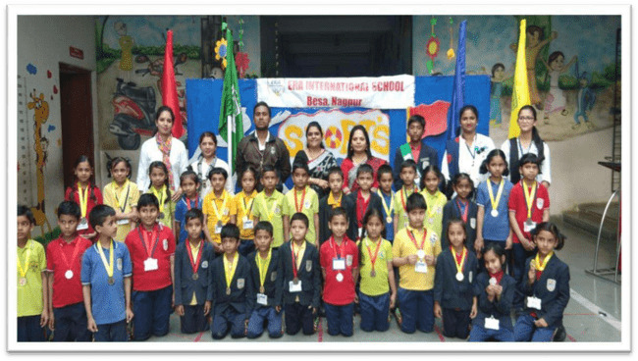
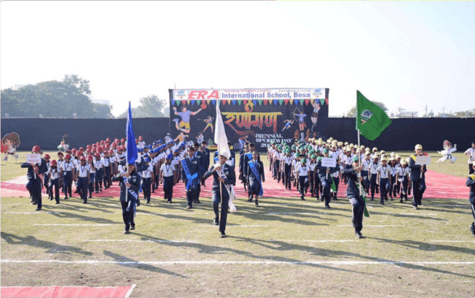

Revati Nagar,Besa,
Nagpur - 440037
www.erabesa.co.in


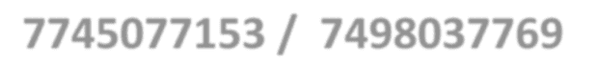

erainternationalbesa@gmail.com

Values
Confidence, Independence, Persistence, Resilience, Respect.

Objectives
School is committed to:
- To provide an educational program that develops student’s curiosity and creativity.
- To develop responsible and engaged learners.
- To foster tolerance, respect and acceptance of others.
- To build each student’s resilience and self-esteem.
- To provide a curriculum that is rich and relevant and allows all students to succeed.
- To promote a strong, supportive partnership between home and the school and the wider community.
- To have high expectations of ourselves and others.

Vision :
To create an inclusive community where every student thrives academically, socially, and emotionally, fostering a love for learning.

Mission :
Our mission is to educate the whole child by promoting academic success, emotional resilience, and ethical citizenship through diverse and inclusive learning experiences.

Instructions :-
  - Please go through the parent guideline booklet regularly to know the test and activity schedules.
  - Read rules and regulations carefully in the booklet given.
  - The holiday list is also given in the last page.
  - The schedule of PTM during session will be informed timely through circular.
  - Every 2nd & 4th Saturday will be holiday for students.
  - Parent teacher Meet will be there on every 4th Saturday of the month.
  - Any change in address or telephone numbers should be intimated to the class teacher for necessary changes in school records.
  - We expect you to give attention to your ward’s punctuality, regularity, discipline, neatness and take interest in their work.
  - 90% attendance is compulsory for promotion to the next class.

Hoping for co-operation from your end while we strive for excellence in nurturing your child.

Wishing you a fulfilling year ahead !

Examination Schedule for the Session 2026-27

CLASS | PERIODIC TEST - I | TERM - I | PERIODIC TEST - II | TERM -II
1st  to  5th | 15th July to 22th July 2026 | 01st October to 12th October 2026 | 28th November to 04th December 2026 | 01st March to 12th March 2026
6th to  8th | 15th July to 22th July 2026 | 01st October to 12th October 2026 | 28th November to 04th December 2026 | 01st March to 12th March 2026
CLASS | PERIODIC TEST - I | PERIODIC TEST - II | PERIODIC TEST – III | Final / Pre Board Exam
9th  to  10th | 15th July to 22th July 2026  01st July to  10th July 2026 | 10th September to  23rd September 2026 | 28th November to  04th December 2026 | 9th std:-01st March to 12th March 2026  10th std:-04th January to 20th January 2026

Note :- All dates are tentative and subject to change as per the decision of school authorities or guidelines issued by DOE/CBSE.


ERA INTERNATIONAL SCHOOL, BESA
EXAMINATION & PROMOTION POLICY SESSION 2026-27
CLASSES I & II

Scholastic Area | Periodic Test-I | Notebook upkeep | Subject Enrichme nt | Term-I | Periodi c Test-II | Notebook upkeep | Subject Enrichme nt | Term-II
Month | July | April to September  (May,June month holiday) | April to September | Octobe r | December | November to March | November to March | March(1st  week)
Max. Marks | 40 M | 10 Marks  (5M-Regularity & Neatness  5M-Worksheets) | 10 M | 40M | 40 M | 10 Marks  (5M-Regularity & Neatness 5M -  Worksheets) | 10 M | 40M
Weightage | 40 M | 10 M | 10 M | 40M | 40 M | 10 M | 10 M | 40M
Weightage | Term - I = 100 Marks |  |  |  | Term - II = 100 Marks
EXAMINATION & PROMOTION POLICY FOR CLASSES III TO V
Scholastic Area | Periodic Test-I | Notebook upkeep | Subject Enrichme nt | Term-I | Periodi c Test-  II | Notebook upkeep | Subject Enrichment | Term-II
Month | July | April to September  (May,June month holiday) | July to September | Octobe r | December | November to March | November to March | March  (1st week)
Max. Marks | 40 M  (To be converte d into  20M) | 10 Marks  (5M-Regularity & Neatness  5M-Worksheets) | 10 M | 60M | 40 M  (To be converte d into  20M | 10 Marks  (5M-Regularity & Neatness 5M -  Worksheets) | 10 M | 60M
Weightage | 20 M | 10 M | 10 M | 60M | 20 M | 10 M | 10 M | 60M
Weightage | Term - I = 100 Marks |  |  |  | Term - II = 100 Marks
Co-scholastic Area  (3-point scale) A-Outstanding  B -Very Good  C - Fair | - Work Education or pre-vocational Education  - Art Education  - Health & Physical Educat ion(Sports/Martial Arts) |  |  |  | Co-scholasti c Area  (3-  point scale)  A-  Outstanding B -Very Good  C - Fair | - Work Education or pre-vocational Education  - Art Education  - Health & Physical Education(Sports/Martial Arts) |  | - Skill based Activities  -  Dance/Music  / Art & Craft  -  Sports/Mart ia l Arts
3.Discipline (3-Point Scale) A-Outstanding  B -Very Good  C - Fair | COMPONENTS :  Attendance/Sincerity/ Behaviour / Values/Tidiness / Respectfulness for rules and regulation/attitude towards society.  (CLASSTEACHER)

PROMOTION POLICY / RULES

- In order to be declared as “Pass” a student should obtain at least 33% or more than 33% in each of the five subjects separately and in aggregate.
- Student has to secure 33% marks out of overall 20 marks in each subject in Internal Assessment too.
- A student having less than 75% attendance in an academic session shall not be permitted to appear in the Final Examinations.
- Students will be awarded Marks as well as grades.
- It is mandatory to appear in all Examinations.
Grading System

Scholastic Areas :-

Grade | Marks Range | Grade Point | - Minimum qualifying Grade in all the subjects  under Scholastic Domain is D.  - 32 and below (E) :-Needs Improvement. In special case will be detained.
A1 | 91 - 100 | 10.0
A2 | 81 - 90 | 9.0
B1 | 71 - 80 | 8.0
B2 | 61 - 70 | 7.0
C1 | 51 - 60 | 6.0
C2 | 41 -50 | 5.0
D | 33 - 40 | 4.0
E | 21 - 32 | 3.0

Co-Scholastic Areas :-

Grade | Grade Point | Minimum qualifying grade in Co-Scholastic Domain is C
A | 4.1 – 5.0 | Minimum qualifying grade in Co-Scholastic Domain is C
B | 3.1 – 4.0 | Minimum qualifying grade in Co-Scholastic Domain is C
C | 2.1 - 3.0 | Minimum qualifying grade in Co-Scholastic Domain is C

MIDDLE SCHOOL EXAMINATIONS ( VI TO VIII )
SCHEME OF EXANMINATIONS AND ASSESSMENTS
- The academic year is divided into two terms and examination will be conducted in the end of the each term.
- Evaluation of the scholastic aspect will be conducted according to C.B.S.E guidelines which are tabulated below.
- Attendance for the all examination is mandatory.
- Re-test will be conducted only for that student who will be represented school or medical condition. If any medical condition will be there at the time of examination medical certificate should be submitted.
- Student found using unfair means during examination will be marked zero in that subject. These student will not be eligible for any award.
- The final result will be calculated by taking 10% weightage of the periodic Test + 10%
- Weightage of Note book, Subject Enrichment Activities and Attendance + 80% weightage of half yearly and Final exam.
- We hope that with the cooperation and support of the parents, we shall be able to make success of this system which is a path breaking initiative taken by CBSE to aspire for holistic development of the students .

PROMOTION POLICY / RULES

- In order to be declared as “Pass” a student should obtain at least 33% or more than 33% in each of the five subjects separately and in aggregate.
- Student has to secure 33% marks out of overall 20 marks in each subject in Internal Assessment too.
- A student having less than 75% attendance in an academic session shall not be permitted to appear in the Final Examinations.
- Students will be awarded Marks as well as grades in classes VI & VII.
- It is mandatory to appear in all Examinations.

EXAMINATION & PROMOTION POLICY CLASSES VI & VIII

Scholastic Area | Periodic Test-I | Notebook upkeep | Subject Enrichme nt | Term- I | Period ic Test-  II | Notebook upkeep |  | Subject Enrichm ent |  | Term-II
Month | July | April to September  (May,June month holiday) | April to September | October | December | November to March |  | November to March |  | March (1st week)
Max.Marks | 40 M | 10  Marks/month (5M-Regularity & Neatness 5M-  Worksheets) | 10 M | 80M | 40 M | 10Marks / month (5M-  Regularity & Neatness 5M -  Worksheets) |  | 10 M |  | 40M
Weightage | 10 M | 5 M | 5 M | 80M | 10 M | 5 M |  | 5 M |  | 80M
Weightage | Term - I = 100 Marks |  |  |  | Term - II = 100 Marks
Syllabus | June to August |  |  | June to  October | November -  January |  |  |  | Nov to March
Co-scholastic Area  (3-point scale)  A-  Outstanding B -Very Good  C - Fair | - Work Education or pre-vocational Education  - Art Education  - Health & Physical Education(Sports/Martial Arts) |  |  |  | Co-scholasti c Area  (3-point scale)  A-  Outstandi ng B - Very Good  C - Fair |  | - Work Education or pre-vocational Education  - Art Education  - Health & Physical Education(Sports/Martia l Arts) |  | - Skill based Activities  -  Dance/Music/ Art & Craft  -  Sports/Martial Arts
3.Discipline (3-Point Scale)  A-  Outstanding B -Very Good  C - Fair | COMPONENTS :  Attendance/Sincerity/ Behaviour / Values/Tidiness / Respectfulness for rules and regulation/attitude towards society.

Grading System

Scholastic Areas :-
Grade | Marks Range | Grade Point | - Minimum qualifying  Grade in all the subjects under Scholastic  Domain is D.  - 32 and below (E) :-Needs Improvement. In special case will be detained.
A1 | 91 - 100 | 10.0
A2 | 81 - 90 | 9.0
B1 | 71 - 80 | 8.0
B2 | 61 - 70 | 7.0
C1 | 51 - 60 | 6.0
C2 | 41 -50 | 5.0
D | 33 - 40 | 4.0
E | 21 - 32 | 3.0

Co- Scholastic Areas :-

Grade | Grade Point | Minimum qualifying grade in Co-Scholastic Domain is C
A | 4.1 – 5.0 | Minimum qualifying grade in Co-Scholastic Domain is C
B | 3.1 – 4.0 | Minimum qualifying grade in Co-Scholastic Domain is C
C | 2.1 - 3.0 | Minimum qualifying grade in Co-Scholastic Domain is C

HIGH SCHOOL EXAMINATION POLICY (CLASS :- IX & X )

SCHEME OF EXANMINATIONS AND ASSESSMENTS.
With the restoration of class X Board examination with effect from Academic Year 2017-18, The assessment structure and examination pattern for class IX will be similar for that of class X.
- The academic year is divided into three periodic Assessments and Final examination will be conducted in the end of the year.
- Evaluation of the scholastic aspect will be conducted according to C.B.S.E guidelines which are tabulated below.
- Attendance for the all examination is mandatory.
- Re-test will be conducted only for that student who will be represented school or medical condition. If any medical condition will be there at the time of examination medical certificate should be submitted.
- Student found using unfair means during any test or term examination will be marked zero in that subject. These student will not be eligible for any academic award.
- We hope that with the cooperation and support of the parents, we shall be able to make success of this system which is a path breaking initiative taken by CBSE to aspire for holistic development of the students.
PROMOTION POLICY / RULES
- In order to be declared as “Pass” a student should obtain at least 33% or more than 33% in each of the five subjects separately and in aggregate.
- Student has to secure 33% marks out of overall 20 marks in each subject in Internal Assessment too.
- A student having less than 75% attendance in an academic session shall not be permitted to appear in the Final Examinations.
- Students will be awarded Marks as well as grades in class IX.
- It is mandatory to appear in all Examinations.

EXAMINATION & PROMOTION POLICY FOR CLASS – IX & X SESSION 2026-27

Scholastic Area | Periodic Test-I | Periodic Test-II | Periodic Test-III | Notebook upkeep  (Regularity, Assignment completion, Neatness & upkeep) | Subject Enrichment  (ASL, Practical lab Work, Map Work, Project Work Based on Subject) | FINAL EXAM
Month | July | September | November |  |  | For 10th -  January  (1st week)  Pre-Boards  For 10Th February  For 9th –  March (1st week)
Syllabus | April - July | April- Sept | Sept – Dec (Including some important chapters  of PT-II) |  |  | Entire Syllabus
Max.Marks | 40 M | 40 M | 40 M | 10Marks/month (5M-Regularity & Neatness  5M -Worksheets) | 10 M | 80M
Weightage | 10 M | 10 M | 10 M
Weightage | 10 M (Average of best two periodic Tests) |  |  | 5 M | 5 M | 80M
Total Marks | 100 M
Co-scholastic Area  (3-point scale) A-  Outstanding  B -Very Good  C - Fair | - Work Education or pre-vocational Education  - Art Education  - Health & Physical Education(Sports/Martial Arts/yoga NCC/Music/Dance)  -
3.Discipline (3-Point Scale)  A-  Outstanding  B -Very Good  C - Fair | COMPONENTS :  Attendance/Sincerity/ Behaviour / Values/Tidiness / Respectfulness for rules and regulation / Attitude towards society.

Grading System

Scholastic Areas :-

Grade | Marks Range | Grade Point | - Minimum qualifying Grade in all the subjects  under Scholastic Domain is D.  - 32 and below (E) :-Failed.
A1 | 91 - 100 | 10.0
A2 | 81 - 90 | 9.0
B1 | 71 - 80 | 8.0
B2 | 61 - 70 | 7.0
C1 | 51 - 60 | 6.0
C2 | 41 -50 | 5.0
D | 33 - 40 | 4.0
E | 21 - 32 | 3.0

Co- Scholastic Areas :-

Grade | Grade Point | Minimum qualifying grade in Co-Scholastic Domain is C
A | 4.1 – 5.0 | Minimum qualifying grade in Co-Scholastic Domain is C
B | 3.1 – 4.0 | Minimum qualifying grade in Co-Scholastic Domain is C
C | 2.1 - 3.0 | Minimum qualifying grade in Co-Scholastic Domain is C


ERA INTERNATIONAL SCHOOL,BESA, Nagpur
CBSE Affiliation No. 1131050
HOLIDAY LIST 2026-27
Sr. No. | Name of Festivals | Date | Day
1 | Maharashtra Din | 1st May 2026 | Friday
2 | Buddha Purnima | 1st May 2026 | Friday
3 | Bakri Id | 28th May 2026 | Thursday
4 | Muharram | 26th June 2026 | Friday
5 | Parsi New Year | 15th Aug. 2026 | Saturday
6 | Independence day | 15th Aug. 2026 | Saturday
7 | Nagpanchami | 17th Aug. 2026 | Monday
8 | Eid-e-Milad | 26th Aug. 2026 | Wednesday
9 | Tanha Pola | 11th Sept. 2026 | Friday
10 | Ganesh Chaturthi | 14th Sept. 2026 | Monday
11 | Mahalakshmi Pooja | 18th Sept. 2026 | Friday
12 | Anantchaturdashi | 25th Sept. 2026 | Friday
13 | Gandhi Jayanti | 2nd Oct. 2026 | Friday
14 | Savapitri Amavasya | 10th Oct. 2026 | Saturday
15 | Dhammachakra Pravartan Din | 14th Oct. 2026 | Wednesday
16 | Dussehra | 20th Oct. 2026 | Tuesday
17 | Gurunanak Jayanti | 24th Nov. 2026 | Tuesday
18 | Christmas | 25th Dec. 2026 | Thursday
19 | Makar- Sankranti | 15th Jan. 2027 | Friday
20 | Republic Day | 26th Jan. 2027 | Tuesday
21 | Akshay Tritiya | 3rd Feb 2027 | Wednesday
22 | Shivaji Jayanti | 19th Feb. 2027 | Thursday
23 | Maha- Shivratri | 6th March 2027 | Saturday
24 | Ramadan Id | 10th March 2027 | Wednesday
25 | Holi | 22nd March 2027 | Monday
26 | Good Friday | 26th March 2027 | Friday
27 | Gudhi Padwa | 7th April 2027 | Wednesday
28 | Dr. Babasaheb Ambedkar Jayanti | 14th April 2027 | Wednesday
29 | Ram Navami | 15th April 2027 | Thursday
30 | Mahavir Jayanti | 18th April 2027 | Sunday

VACATIONS :-1) Diwali : 6th Nov 2026 to 15th Nov 2026
2) Christmas : 25th Dec 2026 to 1st Jan. 2027
NOTE :- 1) Holidays are subject to change as per the Government Gazette.
2) Collector declared holidays will be informed on time.

